**INVOICE NOTES**

1. Invoice Notes are notes that are added to any POSTED invoice that are specific to that invoice
2. Go to AQ1 (Customer Invoice Inquiry). Type in the invoice number in the invoice# field and hit enter.
3. While on this same screen Click the “$” button on the top of the screen.

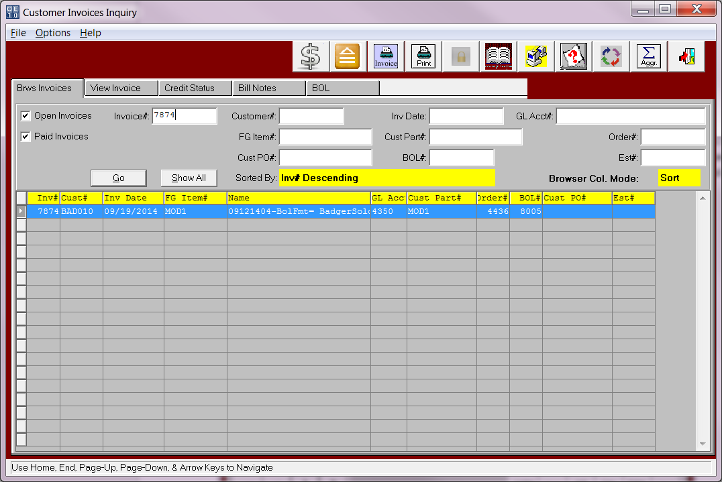

1. After you click the “$” the below screen will pop up. Click the ADD button and type in the notes for this specific invoice only.

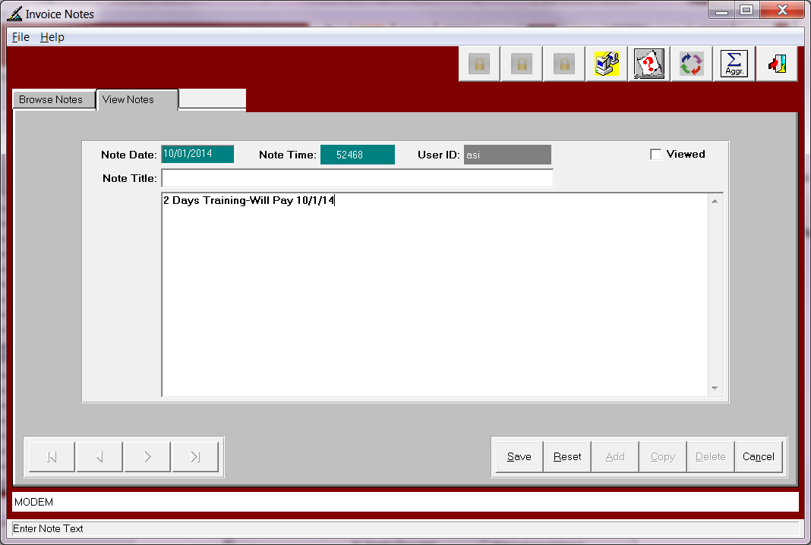

1. Once you have your Invoice notes added you can then print them on the AR Aging Report. On the AR Aging print screen check the toggle box (Print Invoice Notes).

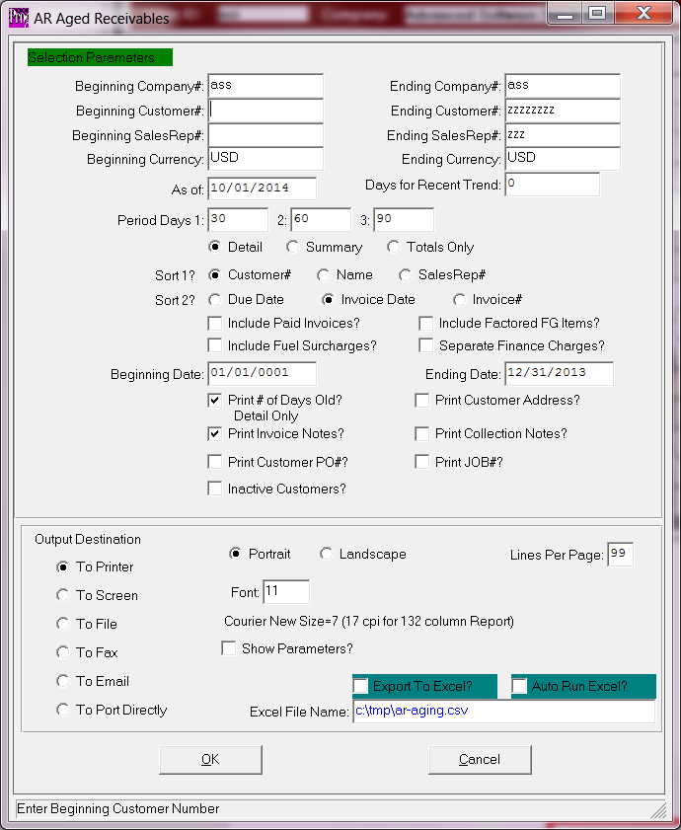

1. Your notes will then print directly underneath that invoice on the aging report.